NATIONAL COMMUNICATIONS AUTHORITY

**QUALITY OF VOICE SERVICE REPORT- MTN**

**GREATER ACCRA REGION**

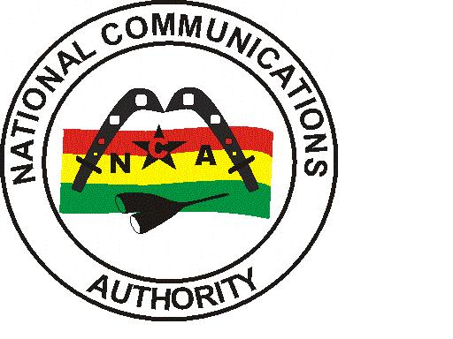

|  |
| --- |
| NCA Tower, Airport City P.O Box CT1568 Cantonments-Accra | April 2021 |

Contents

1 EXECUTIVE SUMMARY 3

2 INTRODUCTION 4

3 MEASUREMENT AND POST-PROCESSING SYSTEMS 4

3.1 GENERAL FEATURES 4

3.2 COVERAGE 4

3.3 VOICE SERVICES 4

4 MEASUREMENT SEQUENCE 5

5 PARAMETERS, DEFINITIONS AND FORMULAE 7

6 FINDINGS AND ANALYSIS 7

6.1 SUMMARY RESULTS 9

6.1.1 KPIs 9

6.1.2 COVERAGE/SPEECH QUALITY PLOTS 10

6.1.3 MOS SAMPLING DISTRIBUTION 18

7 CONCLUSION 18

**TABLE OF FIGURES**

Figure 1. Test Script Sample for Voice Test 6

Figure 2. Abokobi Network Coverage Map 10

Figure 3. Abokobi Speech Quality Plot 10

Figure 4. Adenta Network Coverage Map 11

Figure 5. Adenta Speech Quality Plot 11

Figure 6. Ashaiman Network Coverage Map 12

Figure 7. Ashaiman Speech Quality Plot 12

Figure 8.Darkuman Network Coverage Map 13

Figure 9. Darkuman Speech Quality Plot 13

Figure 10. Madina Network Coverage Map 14

Figure 11. Madina Speech Quality plot 14

Figure 12. Nima Network Coverage Map 15

Figure 13. Nima Speech Quality Plot 15

Figure 14. Nungua Network Coverage Map 16

Figure 15. Nungua Speech Quality Plot 16

Figure 16. Tema Network Coverage Map 17

Figure 17. Tema Speech Quality Plot 17

Figure 18. Speech Quality Chart for MTN, April 2021 18

Table 1. Network Coverage Legend 3

Table 2. Voice Quality Legend 3

Table 3. Monitoring Timetable. 8

Table 4. MTN’s Call Setup Time performance in selected District Capitals in the Greater Accra Region, April, 2021 9

Table 5. MTN’s Speech Quality (MOS) performance in selected District Capitals in the Greater Region, April, 2021 9

# EXECUTIVE SUMMARY

The National Communications Authority (NCA) carried out an assessment of mobile services provided by MTN Ghana in selected District Capitals in the Greater Accra Region by analysing technical parameters that translate into the perception of quality from the user’s standpoint. This was performed from 18th March to 5th April, 2021.

The methodology that was used in this study relies on field tests performed from the user’s standpoint, by using NEMO INVEX II for data collection and NEMO WIND CATCHER for analysis and reporting. Nemo Invex is an automatic measurement system that reflects the several features affecting the quality of the services (end-to-end measurements). Measurements were carried out on equal terms regarding the four (4) operators at the same time, at the same locations and with the same parameters, thus making it possible to perform comparative analysis of the observed performances. Test was carried out every day for four (4) days in each District Capital.

The main quality indicators analysed, considering the user’s perspective and the services under study are as below:

**Network Coverage** - Signal strength of coverage of the radio networks;

Table 1. Network Coverage Legend

|  |  |  |  |
| --- | --- | --- | --- |
| **From (≥)** | **To (<)** | **Colour (RGB)** | **Grade** |
|  | -110 |  | Non-Existent |
| -110 | -95 |  | Poor |
| -95 | -85 |  | Fair |
| -85 |  |  | Good |

**Voice Call Set Up Time** - period of time that the network takes to establish the communication, after the correct sending of the request (target telephone number);

**Voice Call Audio Quality** - perceptibility of the conversation during a call (see

snapshot below)

Table 2. Voice Quality Legend

|  |  |  |
| --- | --- | --- |
| Range | Colour Code | Rating |
| [1 – 2.5) |  | Poor |
| [2.5 – 3.5) |  | Fair |
| [3.5 – 4.1) |  | Good |
| [4.1– 5) |  | Excellent |

# INTRODUCTION

This report evaluates the Quality of Service (QoS) and Quality of Experience (QoE) for the voice services on the 3G (WCDMA) network.

From a regulatory point of view, the purpose of QoS/QoE is to ensure end to end network service quality and enable consumers of mobile and fixed operators to establish connections with each other.

The technical and methodological options of this study directly influence its results and must be taken into account when analysing. Therefore, the results of the study only reflect the behaviour of the networks on the locations and moments of the measurements.

# MEASUREMENT AND POST-PROCESSING SYSTEMS

The *NEMO INVEX II* system was used for measurements on the field and *NEMO WIND CATCHER* used for the post-processing.

This system which is specifically designed for the analysis and benchmarking of cellular mobile communications systems is made up of the following modules:

1. Mobile User Equipment (NEMO INVEX II) equipped with Samsung Galaxy Note5 for GSM & WCDMA and external GPS.
2. QoS analysis and reporting (NEMO WIND CATCHER) equipped with software licences for table, mapping analysis and also for reporting in excel.

## GENERAL FEATURES

Tests are performed automatically and using the NEMO INVEX II (there is no human intervention or decision during the carrying out of a test).

Voice tests are performed with handsets locked to the 3G (UMTS) infrastructure.

Measurements are carried out on moving vehicle with both calling and target handsets collocated in the same vehicle. All collected parameters are geographically referenced and can be later shown by digital cartography.

## COVERAGE

Network coverage assessment is made by measuring the downlink signal levels, CPICH RSCP (Common Pilot Channel Received Signal Code Power) for WCDMA.

## VOICE SERVICES

These services are evaluated end-to-end, using a “voice call” as the basic test unit.

Test calls are made between two mobile terminal devices. The mobile device moves along the studied route/location, and the calls originated from this terminal equipment are named MOC (Mobile Originated Call).

In order to compare the performance of the Cellular operators, a time frame of 125 seconds is used for making each call during the test sessions. When a call fails either during call set up or in the conversation phase, the next call starts with the next time frame.

The analysis of the voice service at a given location includes the ability to establish and to end calls, as well as the communication’s integrity.

Since the aim of this study is to test voice service, the duration of test calls is set to 90 seconds which is about the average duration of calls routed on the networks. Besides the call’s own duration, the time frame considers time periods that make possible the setting up and ending of a call, and also a 15 second pause between consecutive calls, to prevent possible network constraints regarding signalling or mobility management. After the test call is started, the communication’s integrity – audio quality – is analysed both ways.

# MEASUREMENT SEQUENCE

Measurement profiles define a set of conditions that must be verified in order to correctly assess the service of quality and to guarantee the reliability of the tests. They also include process standardization and the definition of testing and measurement parameters, thus making it possible to perform analyses and compare results.

The test parameters used for the analysis of the voice service present is as below:

Voice calls are performed in series with maximum call set up time of 20 seconds. That is the time required for a call to hit set up before the end of a call window is 20 seconds. The evaluation of the speech quality of successful call is to last for the whole call duration of 90 seconds. The guard time between call windows is 15 seconds. The relationship between Mobile Originating Calls (MOC) and Mobile Terminating Calls (MTC) is 1:0.

The test sequence and activities are controlled by a script (see below for call sequence). The start of the test involves a group of activities that basically involves the preliminary activities and settings carried out in preparation for the voice call. The UEs are locked to 3G. The script starts with the Start Recording activity after which the Measurement Sequence Activities follows.

This begins with a ‘Make a Call’ activity which involves a mobile originated to a mobile terminated call using Samsung Galaxy Note 5 mobile phones. For every successful call, after call is connected, the Voice quality testing begins. Voice quality tests are based on the POLQA Algorithm (Super Wideband). The voice quality test will last for the period of 90 seconds. After this activity, the call is terminated and another 15 second wait period is activated. This serves as a guard time between successive successful calls and also allow for the proper termination and release of traffic channels used for the call.

The script for the measurement profile is represented by the diagram below.

Figure 1. Test Script Sample for Voice Test

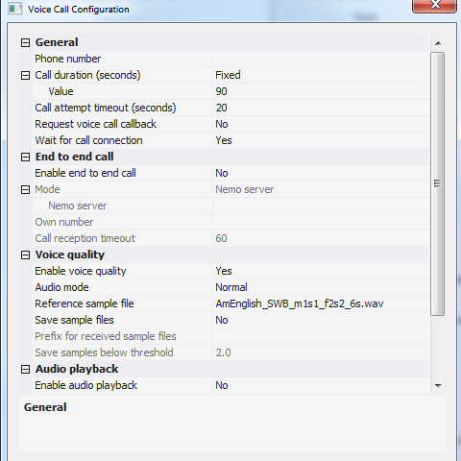

# PARAMETERS, DEFINITIONS AND FORMULAE

This report is on the assessment of quality of cellular mobile voice services provided by MTN in selected District Capitals in the Greater Accra Region.

As per the 3G Licence obligations, the QoS indicators and their respective threshold for compliance under assessment considering the user’s perspective are;

1. **Call Setup Time (CST)**

CST should be less than ten seconds (<10secs) in 100% of cases.

Call Setup Time is defined as the period of time elapsing from the sending of a complete destination address (target telephone number) to the setting up of a call.

For analysis and calculations;



– Moment when an alerting signal is sent to the called terminal

– Moment one hears the call signal on the caller terminal

Only call attempts that were connected (Layer 3 message <<CC: Alerting>> or <<CC:

Connect>>) are considered for analysis.

CST assessment would be 10seconds or less for 95th percentile of samples.

1. **Voice Quality (MOS)**

MOS should meet a minimum score of 3.5 for more than 95% of calls.

Speech Quality (MOS) measures the perception of the audio quality of the conversation of a call.

For analysis and calculations;

Only call attempts that were connected (Layer 3 message <<CC: Alerting>> or <<CC: Connect>>) are considered for analysis.

95% of the connected calls should have a score 3.5 and above.

**NB:** Even though the Licence stipulates that MOS should meet a minimum score of 3.5 for more than 95% of calls, it was assessed using an average of connected calls better than a score of 3.5.

# FINDINGS AND ANALYSIS

The QoS monitoring exercise was started in the Greater Accra Region on 18th March, 2021 at 8:38am and ended on 5th April, 2021 at 1:.20pm.

The test was conducted on perceived busy hour periods depending on the social and business activities and subscriber behaviour in the District Capitals. Test was carried out every day for four (4) days in each District Capital.

Table 3 below indicates detailed locations and times where the tests were conducted.

Table 3. Monitoring Timetable.

|  |  |  |  |
| --- | --- | --- | --- |
| CLUSTER | DATE | TIME | DRIVEN ROUTE |
| A | 03/18/2021 | 08:38 AM - 11:20 AM | NUNGUA |
| B | 03/18/2021 | 14:54 PM - 16:54 PM | DARKUMAN |
| C | 03/19/2021 | 08:17 AM - 10:51 AM | NUNGUA |
| D | 03/19/2021 | 14:43 PM - 17:44 PM | DARKUMAN |
| E | 03/20/2021 | 08:11 AM – 10:43 AM | NUNGUA |
| F | 03/20/2021 | 08:43 AM - 11:22 AM | DARKUMAN |
| G | 03/21/2021 | 10:24 AM – 12:49 AM | NUNGUA |
| H | 03/21/2021 | 13:59 PM - 16:09 PM | DARKUMAN |
| I | 03/22/2021 | 08:33 AM - 10:07 AM | TEMA |
| J | 03/23/2021 | 10:26 AM - 12:04 PM | TEMA |
| K | 03/24/2021 | 09:18 AM- 10:49 AM | TEMA |
| L | 03/24/2021 | 13:16 PM - 16:19 PM | ADENTA |
| M | 03/25/2021 | 08:52 AM - 10:19 AM | TEMA |
| N | 03/25/2021 | 12:55 PM - 15:57 PM | ADENTA |
| O | 03/26/2021 | 10:16 AM - 13:32 AM | ASHAIMAN |
| P | 03/26/2021 | 13:13 PM - 16:15 PM | ADENTA |
| Q | 03/26/2021 | 15:35 PM - 17:14 PM | NIMA |
| R | 03/27/2021 | 07:11 AM - 10:15 AM | ASHAIMAN |
| S | 03/27/2021 | 14:56 PM - 16:16 PM | NIMA |
| T | 03/27/2021 | 13:27 PM - 16:29 PM | ADENTA |
| U | 03/28/2021 | 07:00 AM - 10:02 AM | ASHAIMAN |
| V | 03/28/2021 | 14:10 PM - 15:28 PM | NIMA |
| W | 03/29/2021 | 08:55 AM - 11:49 AM | ASHAIMAN |
| X | 03/29/2021 | 09:10 AM -11:43 AM | ABOKOBI |
| Y | 03/29/2021 | 15:57 PM - 18:15 PM | NIMA |
| Z | 03/30/2021 | 08:34 AM - 10:52 AM | ABOKOBI |
| AA | 03/31/2021 | 08:00 AM – 09:59 AM | ABOKOBI |
| BB | 04/01/2021 | 08:09 AM – 10:24 AM | ABOKOBI |
| CC | 04/02/2021 | 12:28 PM - 18:13 PM | MADINA |
| DD | 04/03/2021 | 10:48 AM - 16:26 PM | MADINA |
| EE | 04/04/2021 | 11:02 AM - 17:01 PM | MADINA |
| FF | 04/05/2021 | 07:33 AM - 13:20 PM | MADINA |



## SUMMARY RESULTS

### KPIs

The Mobile Origination Call (MOC) attempts are used for analysis.

By analysing the technical parameters that translate into the quality perception from the mobile phone user’s standpoint, benchmarking against compliance requirements as per the 3G Licence, the summary of the results of the QoS parameters under consideration are as in Table 4 below:

Table 4. MTN’s Call Setup Time performance in selected District Capitals in the Greater Accra Region, April, 2021

|  |  |  |  |  |  |
| --- | --- | --- | --- | --- | --- |
| **District Capital** | **95th Percentile of Call Setup Time**  **(<10 sec)** | | | | **Meet or Fail Licence Condition** |
| **Day 1** | **Day 2** | **Day 3** | **Day 4** |
| Abokobi | 08.38 | 08.21 | 08.63 | 08.40 | Pass |
| Adenta | 07.72 | 08.24 | 07.63 | 07.45 | Pass |
| Ashaiman | 08.18 | 06.31 | 07.99 | **11.02** | Pass |
| Darkuman | 06.86 | 08.83 | 09.30 | 08.51 | Pass |
| Madina | 08.85 | 08.97 | 08.26 | 07.50 | Pass |
| Nima | 07.32 | 07.72 | 06.66 | 08.64 | Pass |
| Nungua | 08.40 | **10.10** | 08.80 | 07.51 | Pass |
| Tema Community 1 | 08.23 | 08.32 | 07.83 | 08.15 | Pass |

Table 5. MTN’s Speech Quality (MOS) performance in selected District Capitals in the Greater Region, April, 2021

|  |  |  |  |  |  |
| --- | --- | --- | --- | --- | --- |
| **District Capital** | **Average MOS**  **(> 3.5)** | | | | **Meet or Fail Licence Condition** |
| **Day 1** | **Day 2** | **Day 3** | **Day 4** |
| Abokobi | 3.64 | 3.63 | 3.67 | 3.68 | Pass |
| Adenta | 3.68 | 3.69 | 3.70 | 3.71 | Pass |
| Ashaiman | 3.69 | 3.69 | 3.73 | 3.67 | Pass |
| Darkuman | 3.64 | 3.61 | 3.65 | 3.58 | Pass |
| Madina | 3.68 | 3.67 | 3.68 | 3.66 | Pass |
| Nima | 3.68 | 3.71 | 3.72 | 3.67 | Pass |
| Nungua | 3.65 | 3.66 | 3.70 | 3.68 | Pass |
| Tema Community 1 | 3.68 | 3.71 | 3.66 | 3.70 | Pass |

### COVERAGE/SPEECH QUALITY PLOTS

Figure 2. Abokobi Network Coverage Map

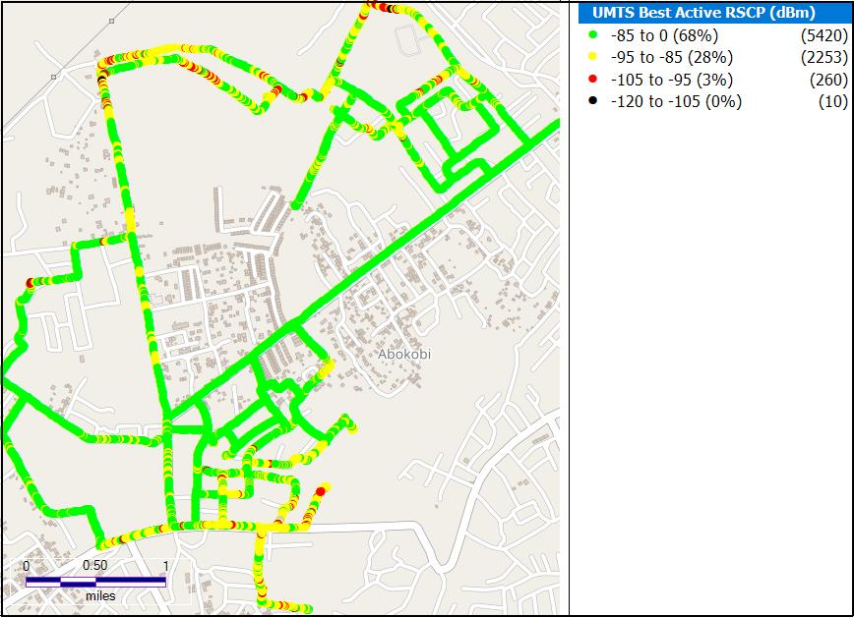

Figure 3. Abokobi Speech Quality Plot

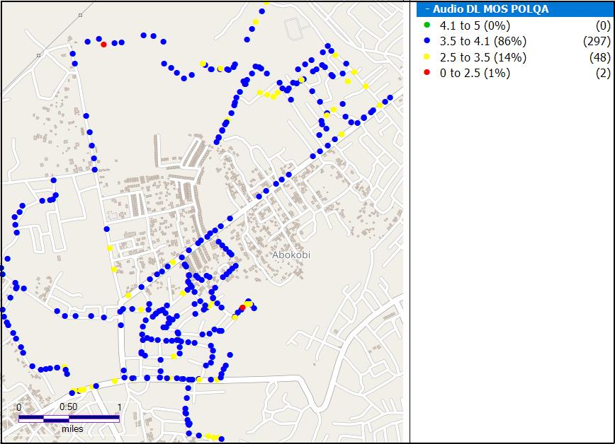

**Remarks**:Good network coverage in Abokobi but requires major improvement in Ga East Health Directorate, Star Oil, Presby and Rural Bank area. Speech quality is good with minor improvement required around the Abokobi Presby and Post Office.

Figure 4. Adenta Network Coverage Map

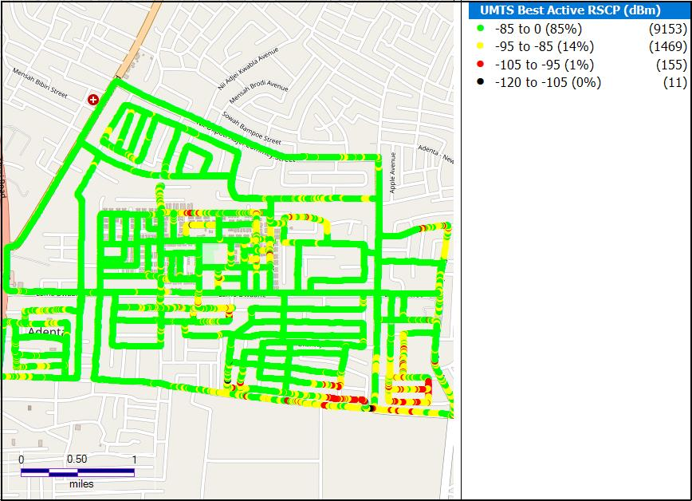

Figure 5. Adenta Speech Quality Plot

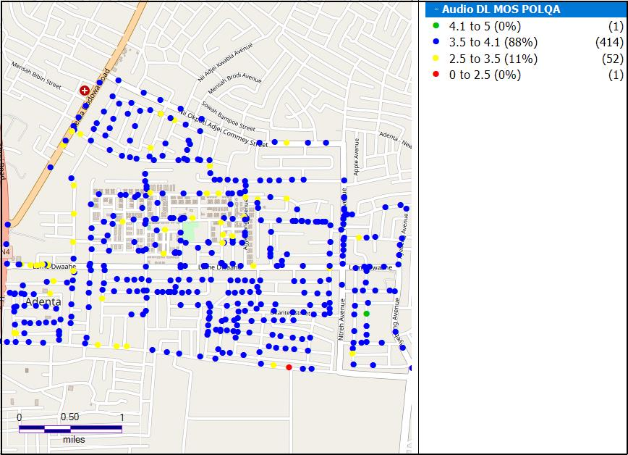

**Remarks**: Good network coverage in Adenta, however major improvement is required around the Lorry station, Osabu link, Municipal Assembly and SSNIT flat areas. Speech quality is good with minor improvement required around the SDA Junction, Adjei Onanor Street, SSNIT and Adenta barrier.

Figure 6. Ashaiman Network Coverage Map

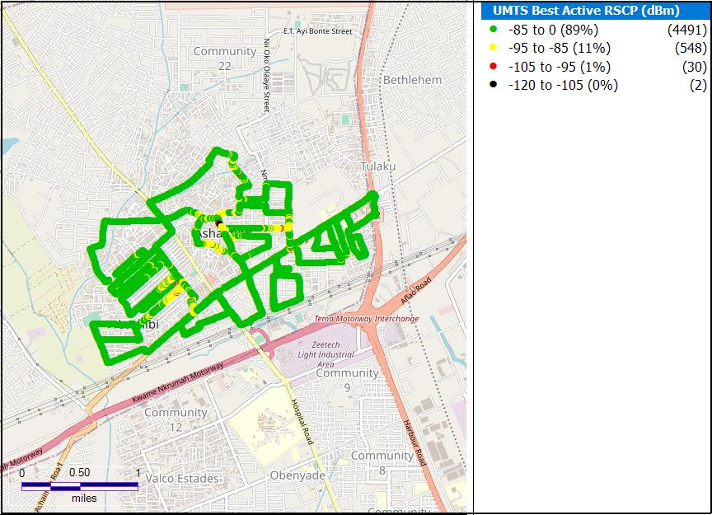

Figure 7. Ashaiman Speech Quality Plot

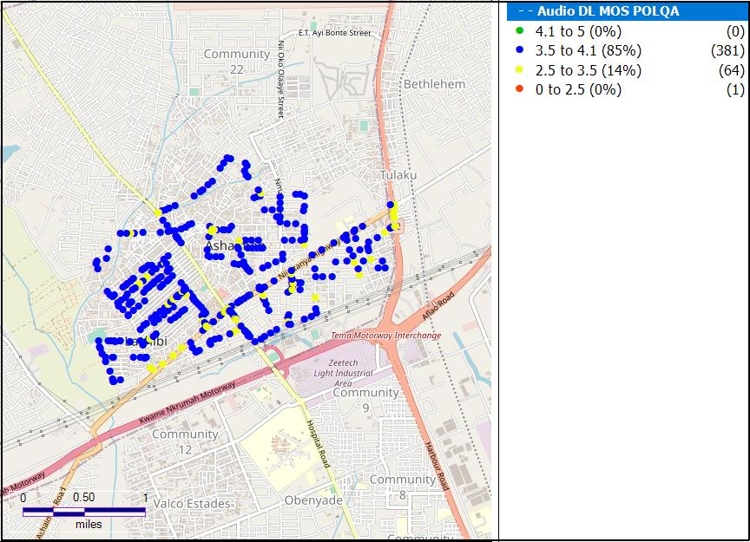**Remarks**: Good network coverage in Ashaiman, however, major improvement is required around Police Station, Market, Suncity Medical Centre and around Ecobank. Good speech quality with minor improvement required around Portuphy link, Market and Tulaku.

Figure 8.Darkuman Network Coverage Map

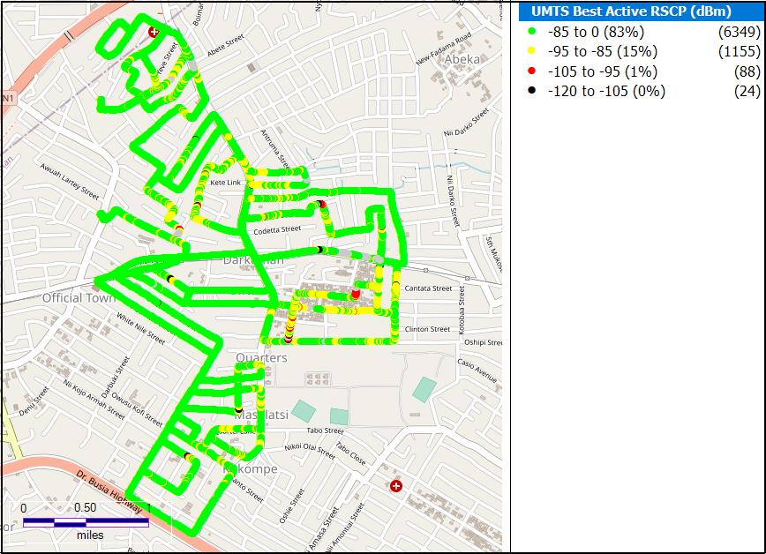

Figure 9. Darkuman Speech Quality Plot

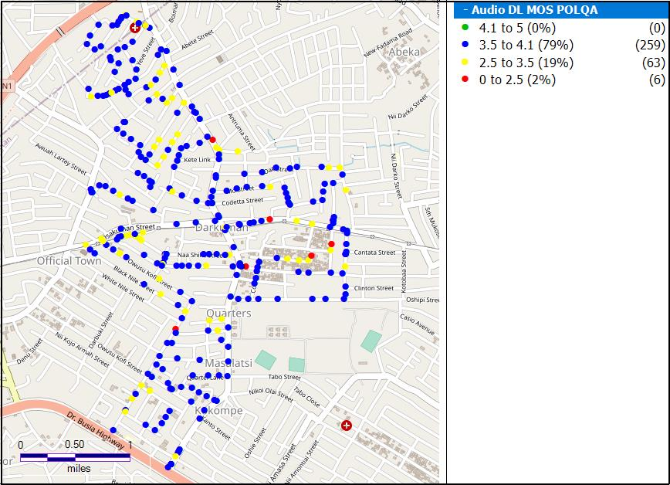**Remarks**: Good network coverage in Dakuman but major improvement is required at the Kete Link, Quarters, Masalatsi, Official Town and Cantata Street. Speech quality is good but minor improvement is needed at the Circle Station, Official Town, Kete Link and Quarters.

Figure 10. Madina Network Coverage Map

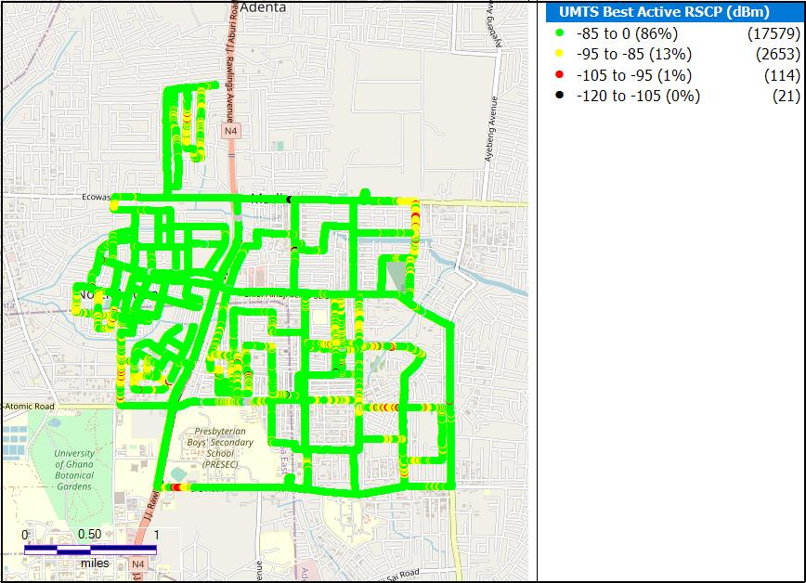

Figure 11. Madina Speech Quality plot

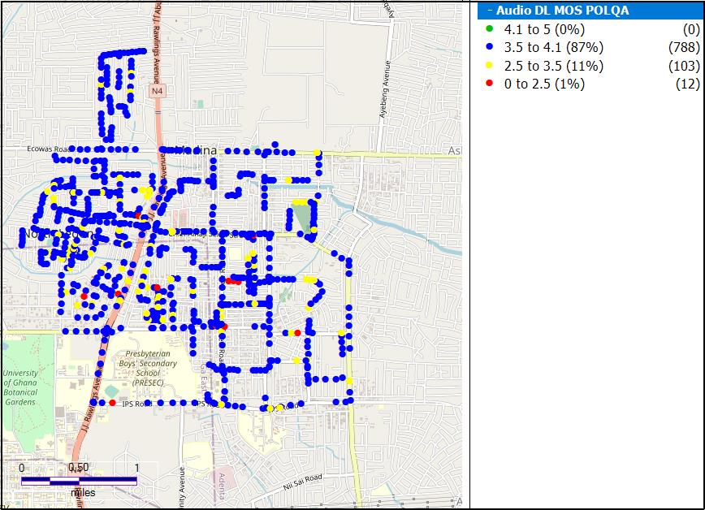

**Remarks:** Good network coverage across Madina, however, major improvement is required around Presec, Dromo Crescent, Mikass Lane, Nile House Mess and Estates. Speech quality is Good but needs minor improvement around Presec, Dromo Cresc, Estates, La Galaria and along the Boundary Road.

Figure 12. Nima Network Coverage Map

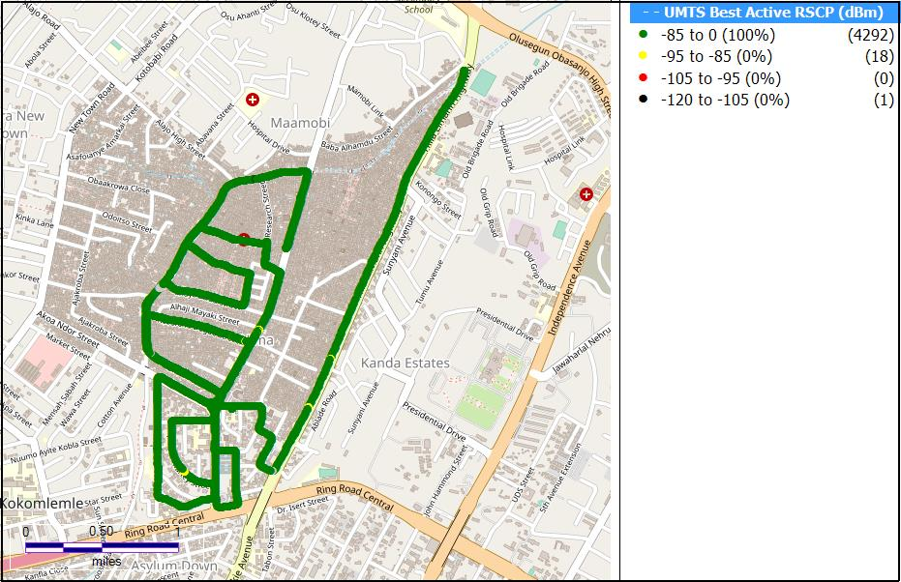

Figure 13. Nima Speech Quality Plot

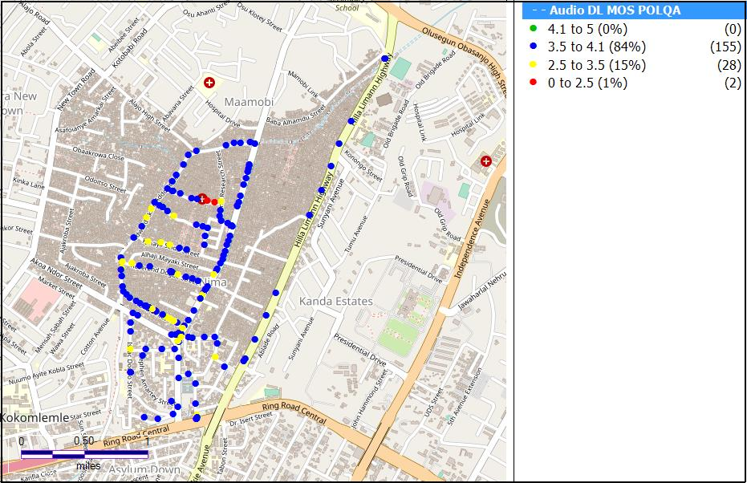**Remarks:** Generally Goodnetwork coverage in Nima with minor improvement needed. Speech quality is good with minor improvement required around the Alhaji Mayaki Street, Hospital and the Market.

Figure 14. Nungua Network Coverage Map

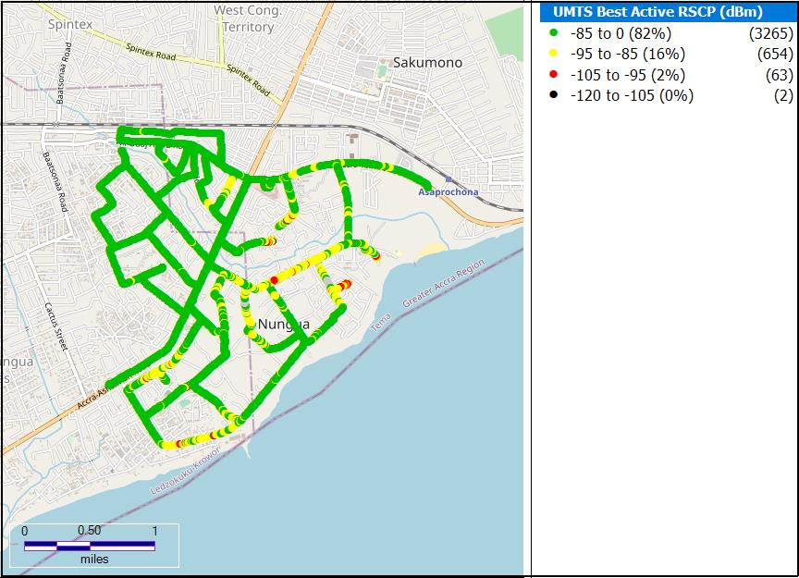

Figure 15. Nungua Speech Quality Plot

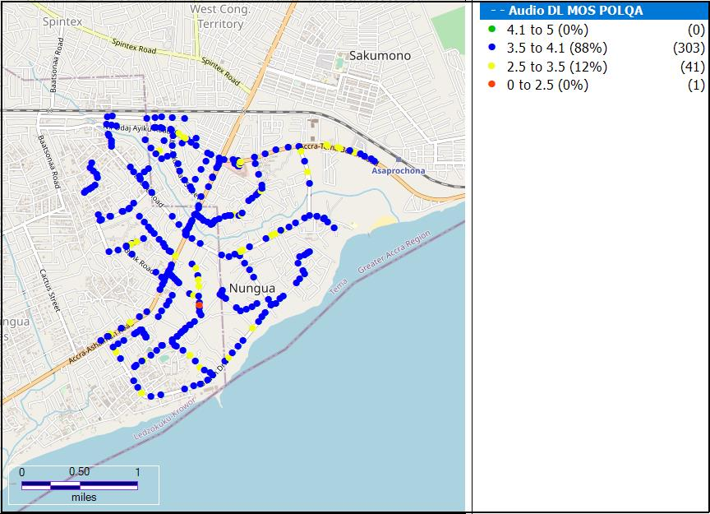**Remarks:** Good network coverage in Nungua with major improvement required along the Junction Mall, Maritime University, Old Town and Beach Road. Speech quality is good; minor improvement required along the Beach Road.

Figure 16. Tema Network Coverage Map

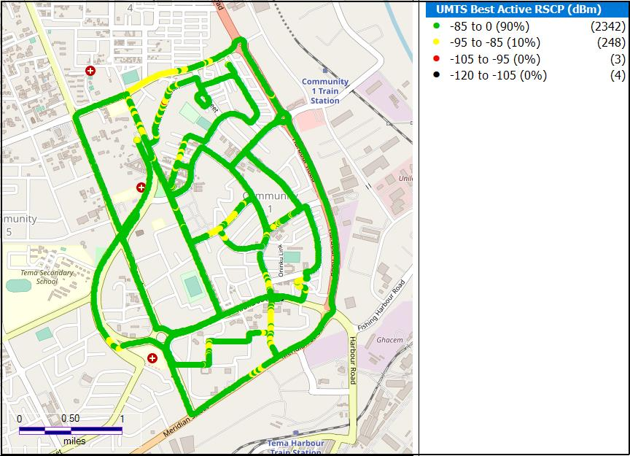

Figure 17. Tema Speech Quality Plot

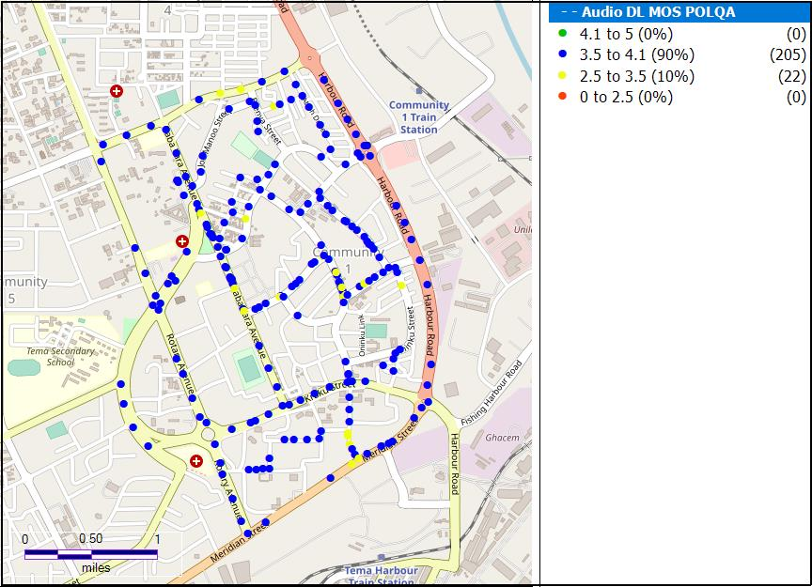**Remarks:** Generally Good network coverage and Speech quality in Tema. Minor improvement is required along the Community 1 – Community 5 road.

### MOS SAMPLING DISTRIBUTION

Figure 18. Speech Quality Chart for MTN, April 2021

**Remarks:** 84% of samples are Good; however, about 16% are Not Good and require improvement.

# CONCLUSION

* MTN met its Speech Quality (MOS) Licence condition in all eight (8) District Capitals tested in the Greater Accra Region.
* MTN met its Call Setup Time (CST) Licence condition in all eight (8) District Capitals tested.
* MTN needs to improve its network coverage in Abokobi, Adenta, Madina, Darkuman and Nungua.